**CE901**

**Chaowen Yang**

**Abstract**

This essay will focus on a table role play game, *Dungeons and Dragons 5th edition*, and using programmer to simulate game play to find if there are any unbalanced elements in the game. Ability check, weapons’ damage rate, and saving throw will be tested at the version v1.0. 12 races and 14 classes compose 168 different combination, and programmer version v2.2. will test them all in three respects, exploration, social interaction, and combat. All result could be found at the GitHub and important information will be contained into the report. In the test, class *Fighter* and *Rogue*, race *Half-Orc*, *Halfling: Stout*, and *Halfling: Lightfoot* shows better result than others. However, class *Wizard* and *Sorcerer*, race *Half-Elf*, *Human*, *Dragonborn* and *Gnome: Forest Gnome* are week at this test. The reason is varied and may because of the lack of the test system. For the future plan, by add more function, it could benefit the result and enhance it to make the result more believable.

**Content**

1. Introduction 4

2. Dice and tools 5

2.1. Dice 5

2.2. Tools 5

3. More about D&D 6

3.1. OD&D 6

3.2. Branch of *D&D* 6

3.2.1. *AD&D* and *AD&D 2e* 6

3.2.2. *BD&D* 6

3.3. *D&D 3e* and *D&D 3.5e* 6

3.4. *D&D 4e* 7

3.5. *D&D 5e* 7

4. Study Area and Expected Result 7

4.1. Three analyses area 8

4.2. Background research //TODO: add more 8

4.3. Expected result 10

5. Methodology 10

5.1. Version 1.0 11

5.1.1. Success to pass a quest in different modify level 11

5.1.2. Weapons’ damage rate 12

5.1.3. Saving Throw Success Chance 13

5.2. Version 2.2 13

5.2.1. About the player class 13

5.2.2. How good the combination at exploration 14

5.2.3. How good the combination at social interaction 17

5.2.4. About the Enemy class 18

5.2.5. How good the combination at combat 18

5.2.6. How good the combination for all test 20

6. Implement code 20

6.1. Version 1.0 21

6.1.1. Structure 21

6.1.2 Success to pass a quest in different modify level 22

6.1.3. Weapons’ damage rate 23

6.1.4. Saving Throw Success Chance 26

6.2. Version 2.2 27

6.2.1. Improvement for Classes 27

6.2.2. Exploration Test 30

6.2.3. Social Interaction Test 32

6.2.4. Combat Test 32

6.3.5. Test Result 34

7. Result and Analyses 34

7.1. Ability Check Result 34

7.2. Weapon damage result 37

7.3. Saving Throw Test Result 40

7.4. Race and Class combination Test 41

7.4.1. Exploration and Social Interaction Test Result 41

7.4.2. Combat Test Result 42

7.4.3. Total Test Result 43

8. Discussion and Conclusion 44

9. References //TODO: Edit format to IEEE style 46

10. Appendix 47

1. Introduction

This report will focus on a tabletop role play game *Dungeons & Dragons (D&D)*, which idea influenced further games’ design. For example, in the game, every character has six main abilities, which are Strength, Dexterity, Constitution, Intelligence, Wisdom and Charisma. These abilities decide the characters’ capability, and higher ability may help the character done a quest easier than the one has lower ability. However, a character will not to be allowed to good at all six abilities, players need to adjust and balance their character’s six ability. Therefore, different strategy of configuration will generate vary outcomes of a single character. After *D&D*, some games made base on its framework and added extra elements, then create a new game. *Final Fantasy XIV* is an example, the character in game has five attributes which are Strength, Dexterity, Vitality, Intelligence and Mind [1]. Not only in this part, on the other hand the race and class of the character are similar with *Dungeons and Dragons* as well. Therefore, to understand the model of *D&D* could be helpful for analysis other games.

For those who have not get a chance to play *D&D* before, this essay will briefly introduce it with its history. In case to avoid misunderstand later, this report will focus on *Dungeons & Dragons* *fifth edition (D&D 5e)*, which released at August 2014. All rules and data chose to be analyses will take from it.

Moreover, this report will collect and summarize some current comments on the website, by comparing and contrasting them to define an expect result of the result. In the end of test, if differences exist, this report could analyses the reason and try to find the key cause the result.

This report used *C#* as coding language and *Visual Studio 2017* as Integrated Development Environment (IDE). In the early research, this report wrote a version 1.0 program but did not realize the complicated structure of the game, so that the logic of programming layout is simple. Latterly, this report updated the version 1.0 to 2.0 and 2.2, which improved the logic by add more class to enhance it operability.

During the analyses, this report will use *Excel 2018* to collect and manage data. It is easier for creating graphs and rank a list by using *Excel 2018*’s functions. Then, this report will evaluate data that collected from programmer version 1.0 and version 2.2.

These two versions come out with some result, but due to the lack of time and some missing part like spells and magics. Hence, the result that this report get could be taken into the consideration during the game play but need to be improved for the better result. Therefore, in the end of this report, it will list some shortcoming that needs to be enhanced.

2. Dice and tools

2.1. Dice

This report will mention dice many times in the rest parts. For easy and shot way to describe dice, roll***n*** number dices, which has ***r*** side and add ***i*** modify will be wrote in this way:

***nDr + i***

For example, “*2D8 +3*” means roll two eight-side dices and add three.

Moreover, D20 means twenty-side dice. Similarly, ***Dr*** mean r-side dice.

2.2. Tools

This report used C# as coding language and Visual Studio 2017 as IDE. Main reason for using C# is this is a common coding language for students who study course about games, and most of them will learn how to use Unity or similar engine. Therefor, for the further study, if possible, next years’ master students could keep improve this programmer and simulate better results.

Moreover, it is easy to transfer to Unity to make a visual simulator, by copy most code and do some modify.

3. More about D&D

3.1. OD&D

*Original Dungeons and Dragons* (*OD&D*) was published in 1974 by *TSR* [3]. It motivated players and publishers; 3,000 copies sold, and similar game made at that time [4]. Not complicated like the fifth edition, the original version only has three classes and four races. In the latter years, supplements consequent on its trade.

3.2. Branch of *D&D*

In the 1774, TSR produced two product lines for D&D; one is *Dungeons & Dragons Basic Set* (*BD&D*), the other one is *Advanced Dungeons & Dragons* (*AD&D*).

3.2.1. *AD&D* and *AD&D 2e*

Next version of *D&D* is *Advanced Dungeons & Dragons* (*AD&D*). Tree books were published between 1977 to 1985, they include *Monster Manual*, *Players Handbook* and *Dungeon Masters Guide (Core rulebooks complete)*. It added more classes, monsters and other updates.

The *Advanced Dungeons & Dragon second edition* (*AD&D 2e*)includes a *Player's Handbook*, *Dungeon Master's Guide* and *Monstrous Compendium* since 1989 to 1995. It changed combat system and introduced Armor Class (AC), which is the prototype of *D&D 5e*’s combat mechanic. In this version character creation is modified as well, more flexible for class choosing, higher max level and spells book.

3.2.2. *BD&D*

Not popular like the *AD&D*, *Dungeons & Dragons Basic Set* has less influence for *D&D* further games. However, it gives rules and character creation at beginning levels so that it helps players who new to tabletop role playing games [5].

3.3. *D&D 3e* and *D&D 3.5e*

Due to the lack of management and the product line is too bloated, D&D series were falling [6]. At that time, *Wizards of the Coast LLC* (simply refer as *WotC* or *Wizards*) purchased *TSR* [7]. Then *Wizards* combined *BD&D* and *AD&D* together as a product line and published third version of D&D, *Dungeons & Dragons 3rd edition* (*D&D 3e*). By using D20 system and enhanced combat system, *D&D 3e* attracted more players back to *D&D* [6].

In 2003, *Dungeons & Dragons 3.5 edition* (*D&D 3.5e*) was produced. It modified unbalance part in D&D 3e, and improved combat system and edited parameters about races and classes [6].

3.4. *D&D 4e*

In the 2008, computer games and video games were going to become the trend of games. *Wizards* changed some rules and cut some core settings to fit the trend. However, those changes caused unsatisfied of some old players. Some players modified *D&D 3.5e* rules, and developed *Pathfinder Role-playing Game* [6]. Taking all influence of *D&D 4e*, *Wizards* published a new version of D&D few years later.

3.5. *D&D 5e*

*Dungeons and Dragons* *fifth edition* (*D&D 5e*), which released at August 2014. It includes the basic knowledge a player needs for playing the game, such as rules of creating a character, exploration and combat. *Wizards* put elements back, which cut off in *D&D 4e*. There are three books included, *Player’s Handbook*, *Dungeon Master’s Guide* and *Monster Manual*.

In this report, we are going to use the *Player’s Handbook* as the main reference to design the programmer and taking parameters.

4. Study Area and Expected Result

In this report, the goal is to write a programmer to simulate game player of *D&D* (*D&D 5e, same version as following report*). There are three pillars of adventure in *D&D*, **exploration**, **social interaction** and **combat**. Exploration and social interaction require player character to do D20 check. Then this report will collect some comments of *D&D* and infer a ratiocination for the result.

4.1. Three analyses area

*D&D* list 9 main race and some of them has few subraces, so that total 14 optional races; 12 main Classes with multiple detail choice total 40 optional classes. Different combination of race and class may vary outcomes of result. Those combination cause difference of player character’s six ability, and they lean to distinct performance.

To evaluating performance of the combination in **exploration** and **social interaction**, we need to test and analyse the expression of the player character’s 18 skills. Those skills influenced by player’s six ability modify, race and class bonus.

For combat part, it is more complicated than other two respects. Due to the lack of time and complex of *D&D* rules, this report only focusses on physic damage, not include spells nor magics. Once a combat start, the player and the enemy both need to roll D20 to decide the order of attack sequence. Then, the attacker needs to roll D20 and add its modify, if the result equal or bigger than defender’s armor class, this attack is success. If the attack check is successful, the attacker will roll dice base on its equipment weapon and add modify. More details will be mentioned in the section 5.

4.2. Background research //TODO: add more

By searching on the internet, there are some comments for *D&D 5e*. Here are six groups created by a user Sant [9] at goddessfantasy.net

Environmental occupation: Paladin

Secondary environment: Barbarian, Fighter

Top: Bard, wizard, Warlock

Superior: Druid, Ranger

Backbone: Sorcerer, Monk, Rogue

Vulnerable: Cleric

//Todo: Paraphrase

Another user Flibbertigibbet[10] at rpg.net gave below answer for game balance

1. A Fighter with the right Feats and Battlemaster traits seemed to have much higher damage than most Martial Classes.

2. The Barbarian, Ranger and Warlock looked a little weak.

3. I had the impression a lot of Monsters had pretty scary abilities that required Saving Throws, the Paladin feature seems really good.

4. I couldn't really tell how much gear you were supposed to hand out.

5. I feel like the expected rests per day would not fit how I run my campaigns.

//Todo: Paraphrase

If looking through one more comment on reddit.com wrote by uncleinabucket, he tells that

Rogue- Explosive early rounds, moderate and reliable later rounds. Highest mobility and solid evasion style defenses (even against melee now).

Warrior- Burst on demand with no condition... not super often but you can put the damage exactly where you want it when you want. Solid defense through AC and HP.

Paladin- I agree they have powerful abilities but much of what I read forgets they only have one action per turn. You heal? Your damage is zero. Action economy is still the king of optimization.

Ranger- Extra damage got moved to a spell (hunters mark), extra attacks on par with the round to round fighter (until 11th when fighter pulls away). I look at them like fighters that trade action surge and an extra mid and late game attack for spell casting.

Wizards- Arcane Tradition selection changes the way the wizard plays. All of them looked to be different and useful. This came as a huge surprise to me... in other editions there was no balance between schools. Abjuration and Divination still keep up with old favorites like Evocation.

Sorcerer- Is usually played in our groups by people who love the fire/flight candy. A smaller selection of spells more often and with meta magic twists.

Warlock- Lots of ways to play these guys all look viable. You can let flavor drive you decisions and still come out usable.

Bard- The single most improved class, if inspiration only worked on next attack I would dislike it. Letting players spend it how they please after they see the roll makes it very strong. Spell casting is themed but those few slots you can pick from any list can change everything about the way you play.

Cleric and barb omitted on purpose - I simply have not seen them play yet. From reading, I still think the TL;DR applies to them.

Therefore, by looking through these three comments for players, *D&D* *5e* is not balanced, for [9] tells that Warlock is strong, but [10] thinks it is weaker. The reason could be the different gameplay strategy, but the fact is players hold different opinion for *D&D 5e*, and this is a good chance to analyses it by using programmers.

4.3. Expected result

Due to the research, *Fighter*, *paladin*, and *Barbarian* may has better performance for the test. However, due to the lack of time, spells and magics will not be added to the programmer. It will makes class which need to use spells or magics weeker.

5. Methodology

In this part, this report will focus on methodology and explain how these codes work. There are two version of code in the GitHub, *version 1.0* and *version 2.2*. The first version is for the generate test, which does not consider the different character class and race combination. It simulated

1. Success to pass a quest in different modify level
2. Weapons’ damage rate
3. Saving throw success chance

Due to the lack of logic in the version 1.0, this report rearranged the code by add more classes to make the code more flexible. It improved the programmer so that we could analyses 168 different combination of players’ class and race.

1. How good the combination at exploration
2. How good the combination at social interaction
3. How good the combination at combat
4. How good the combination at all of above

5.1. Version 1.0

5.1.1. Success to pass a quest in different modify level

In this version, this report tests the performance of different level modify, which defined by the character’s abilities. There are 11 levels of modify from -5 to +5, which it shows in the Figure tt. When a character is doing a check, the character will roll 1D20 and add specific ability modify and compare the number with the quest level to decide pass or not. For example, a character is trying to do a Strength check to pick up a heavy store, and his Strength ability is 13. The DM tells the player that the quest level is Hard Success Level, which mean 20. Then the player needs to roll 1D20 and add 1, which comes from its ability modify (see *Table I*), into the number. For instance, the player is lucky, and he rolled 19, which is a very large number. Next, he will add 1 to 19 and get 20. This is just passing the quest. Moreover, in the *Dungeons and Dragons* *fifth edition*, it mentions that the player will always get fail if 1D20 result is 1; the player will always get success if 1D20 result is 20.

|  |  |  |  |  |  |
| --- | --- | --- | --- | --- | --- |
| Ability | Modify | Ability | Modify | Ability | Modify |
| 0-1 | -5 | 8-9 | -1 | 16-17 | +3 |
| 2-3 | -4 | 10-11 | 0 | 18-19 | +4 |
| 4-5 | -3 | 12-13 | +1 | 20 | +5 |
| 6-7 | -2 | 14-15 | +2 |  |  |

Table I: ability and modify

Above shows an example for one kind of ability check, to get a better analyses outcome. This report will write a function in C# to simulate rolling a dice. Therefore, keeping rolling dice with large times and add different ability modify to see how good it will pass different level of quests. The quest’s difficulty level is shows in the *Table II*.

|  |  |
| --- | --- |
| Difficulty Level | Threshold |
| Very Easy success | 5 |
| Easy success | 10 |
| Medium success | 15 |
| Hard success | 20 |
| Very hard success | 25 |
| Nearly impossible success | 30 |

Table II: difficulty level and threshold

5.1.2. Weapons’ damage rate

In the *D&D*, player character could choose a lot of weapons. To find which weapon is worth to purchase in the total 37 weapons, this report will use the version 1.0 to simulate the result.

Weapon’s damage rate is relative to the weapon’s damage dice, player character’s ability modify, and enemy’s armor class. Weapon’s damage dice is fixed and it wrote on the rules book. Player character’s ability modify is changeable and it depends on the different class and race. Enemy’s armor class is varying base on the different enemy. Therefore, the function could be written as

$$D=\frac{\sum_{0}^{t_{s}}{d_{n}*{rdm}_{d_{r}}+d_{i}}}{t_{s}}$$

Where

***D*** is the damage rate

$d_{n}$ is the weapon damage dice’s ***n***

${rdm}_{d_{r}}$ is a random number between 0 to weapon damage dice’s ***r***

$d_{i}$ is the weapon damage dice’s ***i***

$t_{s}$ is the attack check test successful time, it come from

$$t_{s}=\sum_{0}^{t}{{+1 if[(rdm}_{20}+ p_{abm})≥e_{ac}}]$$

***t*** is the total test times

${rdm}_{20}$ is a random dice between 1 to 20

$p_{abm}$ is the player character’s ability modify

Therefore, by setting a test time and weapon’s list, it is easy to be wrote into a loop and test them one by one.

5.1.3. Saving Throw Success Chance

Saving throw will be rolled when the player character’s health point equal or less than zero. At that time, the player character has two counters, ***success*** and ***fail***. Then the player character need to roll D20 until the ***success*** or ***fail*** get three times. The count is ruled as

***success*** +1 when ${10≤ rdm}_{20}<20$

***success*** +2 when ${rdm}_{20}=20$

***fail*** + 1 when ${rdm}_{20}<10$

***fail*** + 2 when ${rdm}_{20}=1$

Therefore, keep rolling dice when ***success*** or ***fail*** not get three. If repeat this process again and again until a large number, then the final result could be the likely how a player character passes the saving throw.

5.2. Version 2.2

In the version 2.2, more class added. More logic form makes the data could be save and take easier than the version 1.0. The version 2.2 is improved by the version 2.0, and fixed bugs. Hence, this report could reach the goal to analyze *D&D*.

5.2.1. About the player class

To create a player character, we need to know two basic things, class and race. Different class and race has different affection for the player character’s ability, weapons and armors. For example, class *Barbarian* start with weapons "*Great Axe*", "*Hand Axe*" and "*Javelin*", but class *Bard* start with weapons "*Rapier*", "*Longsword*" and "*Dagger*". Therefore, once we have chosen race and class, the player’s ability, weapons and armors will be added base on them. Moreover, every player character will have some point to add into ability and this report will chose the approach two on the *D&D rule handbook(change name here)*, which is set six ability from 15,14,13,12,10, and 8. In the report, these number will be added into the player character’s ability automatically and it will be explained in the chapter six. Next, calculate character ability modify and skills, which calculation shows in the *Table III.*

|  |  |  |  |  |
| --- | --- | --- | --- | --- |
| ***abm.STR*** | ***abm.DEX*** | ***abm.INT*** | ***abm.WIS*** | ***abm.Cha*** |
| *Athletics* | *Acrobatics* | *Arcana* | *AnimalHandling* | *Deception* |
|  | *SleightofHand* | *History* | *Insight* | *Intimidation* |
|  | *Stealth* | *Nature* | *Medicine* | *Performance* |
|  |  | *Religion* | *Perception* | *Persuasion* |
|  |  | *Investigation* | *Survival* |  |

Table III: player character ability modify influence (CON influences nothing)

Therefore, there are 18 skills need to be tested. However, not every skill will influence the performance both of the exploration and social interaction, the influence point of each skills will be described detailly in the chapter six.

5.2.2. How good the combination at exploration

To analyses how good the character at the exploration area, it is necessary to calculate the result of every skill with their influence point. It is similar with ability check in the version 1.0, but use ability skills not ability modify. When a player character need to do a skill check, the player character need to roll a D20 and add the skills modify. If the result equal or larger than the threshold, the player character will pass it; otherwise the player character will fail.

Before it, we need a list, *skills lis*t, to contain all skills.

The formula could be wrote as

$$R_{e}=\sum_{s_{i}}^{s_{count}}{r_{s_{i}}× I_{s_{i}}}$$

Where $R_{e}$ is the result of the exploration

$s_{i}$ is the skill on the *skills list*

$s_{count}$ is the amount of the skills

$I_{s_{i}}$ is the influence point of $s_{i}$

$r_{s_{i}}$ is the result of $s_{i}$ test, and it contains three test base on the player statue. The following paragraphs will explain it with more detail.

Every player character has a statue for game, it includes *normal*, *advantage* and *disadvantage*. In the *normal* statue, player character roll dice once and take the result; in the *advantage* statue, player character need to roll dice twice and take the larger one; in the *disadvantage*, player character also roll dice twice but take the small one as result. Therefore, $r_{s_{i}}$ can be wrote as

$r_{s_{i}}$ = ${rn}_{s_{i}} × I_{normal}+{ra}_{s_{i}} × I_{advantage}+{rd}_{s_{i}} × I_{disadvantage}$

Where

${rn}_{s_{i}}$ is the result of $s_{i}$ test when player character under the *normal* statue

$I_{normal}$ is the influence point of *normal* statue

${ra}_{s_{i}}$ is the result of $s_{i}$ test when player character under the *advantage* statue

$I_{advantage}$ is the influence point of *advantage* statue

${rd}_{s_{i}}$ is the result of $s_{i}$ test when player character under the *disadvantage* statue

$I_{disadvantage }$ is the influence point of *disadvantage* statue

Same as Table II, there are five levels of skills check, *Very Easy Success*, *Easy Success*, *Medium Success*, *Medium Success*, *Very hard Success*, and *Nearly Impossible Success*. The threshold of them are 5, 10, 15, 20, 25, and 30. Therefore, for example, ${rn}_{s_{i}}$ can be wrote as:

$${rn}_{s_{i}}= r_{ve} × I_{ve}+ r_{e} × I_{e}+ r_{m} × I_{m}+ r_{h} × I_{h}+ r_{vh} × I_{vh}+r_{ni} × I_{ni}$$

Where $r_{ve}$ is the *Very Easy Success* test result check for $s_{i}$

$I_{ve}$ is the influence point for *Very Easy Success*

$r_{e}$ is the *Easy Success* test result check for $s_{i}$

$I_{e}$ is the influence point for *Easy Success*

$r_{m}$ is the *Medium Success* test result check for $s_{i}$

$I_{m}$ is the influence point for *Medium Success*

$r_{h}$ is the *Medium Success* test result check for $s_{i}$

$I_{h}$ is the influence point for *Medium Success*

$r_{vh}$ is the *Very Medium Success* test result check for $s_{i}$

$I_{vh}$ is the influence point for *Very Medium Success*

$r_{ni}$ is the *Nearly Impossible Success* test result check for $s_{i}$

$I_{ni}$ is the influence point for *Nearly Impossible Success*

Test process of $r_{ve}$, $r_{e}$, $r_{m}$, $r_{h}$, $r_{vh}$, and $r_{ni}$ are same but with different threshold, which can be found at Table II above. For example

$$r_{ve}=\sum_{0}^{t}{{+1 if[(rdm}_{20}+ m_{s_{i}})≥th}]$$

Where ***t*** is the test time of each skills

${rdm}_{20}$: a random dice between 1 to 20

$m_{s_{i}}$ is the $s_{i}$’s modify number

***th*** is the threshold of the *Very Easy Success* test, and here is 5 for $r_{ve}$

${ra}_{s_{i}}$ and ${rd}_{s_{i}}$ are same with ${rn}_{s_{i}}$.

$${ra}_{s_{i}}= r_{ve} × I_{ve}+ r_{e} × I_{e}+ r_{m} × I_{m}+ r_{h} × I_{h}+ r_{vh} × I_{vh}+r_{ni} × I_{ni}$$

$${rd}_{s_{i}}= r_{ve} × I_{ve}+ r_{e} × I_{e}+ r_{m} × I_{m}+ r_{h} × I_{h}+ r_{vh} × I_{vh}+r_{ni} × I_{ni}$$

However, $r_{ve}$, $r_{e}$, $r_{m}$, $r_{h}$, $r_{vh}$, and $r_{ni}$ used slightly different method to calculate it because the *advantage* and *disadvantage* statue. There is an example for $r_{ve}$ under the *advantage* statue.

$$r_{ve}=\sum_{0}^{t}{+1 if[({rdm}_{20}^{larger}+ m_{s_{i}})≥th}$$

Where ${rdm}_{20}^{larger}$ means choose the larger one from two random number, which from 1 to 20. It could be wrote as below|:

For the disadvantage statue, $r_{ve}$ is

$$r_{ve}=\sum_{0}^{t}{+1 if[({rdm}_{20}^{smaller}+ m_{s_{i}})≥th}$$

Where ${rdm}_{20}^{smaller}$ means choose the smaller one from two random number, which from 1 to 20. It could be wrote as below|:

5.2.3. How good the combination at social interaction

Social interaction used same method above but changed influence point $I_{s_{i}}$ in $R_{si}$. The formula is same with exploration test.

$$R_{si}=\sum_{s_{i}}^{s_{count}}{r_{s_{i}}× I_{s_{i}}}$$

Similarly, we are going to use these function below as well

$r_{s_{i}}$ = ${rn}_{s_{i}} × I_{normal}+{ra}_{s_{i}} × I_{advantage}+{rd}_{s_{i}} × I_{disadvantage}$

$${rn}_{s_{i}}= r_{ve} × I_{ve}+ r_{e} × I_{e}+ r_{m} × I_{m}+ r_{h} × I_{h}+ r_{vh} × I_{vh}+r_{ni} × I_{ni}$$

$$r_{ve}=\sum_{0}^{t}{{+1 if[(rdm}_{20}+ m_{s_{i}})≥th}]$$

$$r_{ve}=\sum_{0}^{t}{+1 if[({rdm}_{20}^{larger}+ m_{s_{i}})≥th}$$

$$r_{ve}=\sum_{0}^{t}{+1 if[({rdm}_{20}^{smaller}+ m_{s_{i}})≥th}$$

Therefore, by using 18 skills test check, we could analyses the performance of a player character in exploration and social interaction areas. These results may vary between the different race and class.

5.2.4. About the Enemy class

Before start talk about the combat test, there are some class need to be claimed before it, and one of them is the enemy class. This class is similar with the player class, but simpler. For the enemy only need to consider its ability, hit dice, armor class and weapon (or attack type).

Therefore, in the class, if determine an enemy’s ability, the class can automatically do the calculate to get the ability modify. Hit dice can be wrote as *nDr+i* , and it tells how much health point the enemy has. Hence, every two enemy may have the different health even they are same type and same name. Armor class and weapon is not complicate than player class, every enemy has its fixed armor class and weapon. Then, we can start battle.

5.2.5. How good the combination at combat

Combat test is different with the other two, because there need add more class like weapon, armor and enemy to help this report to do it. Next, this report will explain it and describe the test processes.

Before it, we need a list, *enemy list*, which contains all enemies.

Then test result could be wrote as

$$R_{c}=\sum_{e_{i}}^{e_{count}}{\sum_{t_{0}}^{t_{t}}{r_{e_{i}}}}$$

Where $R_{c}$ is the test result of the combat

$e_{i}$ is the $i^{th}$’s enemy in the *enemy list*

$e_{count}$ is the amount of the *enemy list*

$t_{s}$ is the test time for every enemy

$r_{e_{j}}$ is the combat result with the enemy $e_{i}$

This formula asks the player character battle with every enemy many times, and its shows overall performance of the player character in the combat respect.

$r_{e_{j}}$ could be illuminated by using a figure rather than an equation. The Figure I show the logic of the combat test and its process. At the first, the player and the enemy both need to roll 1D20 to decide who attack first. When the get the same dice result, reroll it. Then, the larger one will attack first, if the defender’s health point equal or less than zero, the attacker get the score. In the test, if the player character wins the battle, the player character will receive one point, otherwise receive nothing.



Figure I: Combat process

*Player attack* and *Enemy attack both* need to use player class and enemy class. For the previous one, player character need to choose a weapon first, then do the *attack check*, which need to roll 1D20 and plus the player character’s modify to against the enemy’s armor class. Once the *attack check* success, the player character could do *damage check*, which need to roll the player character equipped weapon’s damage dice and add player character’s modify. The same damage will be minus from the enemy’s health point.

For the other one, the enemy need to roll 1D20 plus its modify, *attack check*, to against the player character’s armor class, which comes from the player character’s equipped armor. If the enemy pass the *attack check*, then the enemy need to roll its damage dice plus its modify. Same as *Player attack*, but the same damage will be drawback from the player character’s health point.

By keep doing this loop, the final result could show the performance of the player character in combat area.

5.2.6. How good the combination for all test

Once $R_{e}$, $R_{si}$, and $R_{c}$ are calculated, add them together and times their individual influence point to get the final result. It could be explained in

$$R= R_{e}×I_{e}+ R_{si}×I_{si}+R_{c} ×I_{c}$$

Where ***R***means the final result of all test

$I_{e}$ is the influence point of the exploration test

$I_{si}$ is the influence point of the social interaction test

$I_{c}$ is the influence point of the combat test

The reason to use influence point is the $R_{e}$, $R_{si}$, and $R_{c}$ come with different number and the differences may be very large. Hence, to adjust them to a similar level, which means the max value and the min value are closed.

Therefore, this report could use ***R***, $R_{e}$, $R_{si}$, and $R_{c}$ to do the analyses.

6. Implement code

Most code has explained inside the programmer, and some of them could be understand the usage of the function by reading the name. in this part, this report will describe the approaches used to achieve the goal.

6.1. Version 1.0

6.1.1. Structure

In the version 1.0, there is no class for player and enemy yet. The variables could change are six abilities, *Str*, *Dex*, Con, Int, Wis, and Cha. There are two ways set abilities:

***GetAbility()***or ***SetAbility(int Str, int Dex, int Con, int Int, int Wis, int Cha)***

The previous one will get the number the user inputted one by one in Console interface, the latter one will set the number insider the code so that it is not flexible then the first way. Then, the user could add extra abilities bonus from class or race by using

***ExtraAbility(int Str, int Dex, int Con, int Int, int Wis, int Cha*)**

Then, there is a method could update player character ability modify

***CalculateMod();***

An ability will be minus 10 and get the floor result as this ability modify. For an ability smaller than 10, the ability will be minus 1 more to solve a bug. For example, if an ability is **15**, then the ability modify is $\frac{(15-10)}{2}$, and take the floor result of **2.5**, so the ability modify is **2**.

Then, ***CalculateSkills();*** is a function which will pass the different ability modify to the different skills. If there are bonus from the race or class, the use could use ***ExtraSkills(String skill, int proficiency)*** to add the skills. The user just need to claim the name of the skill and the bonus value, and the switch statement will match the skill name and add it to the value.

To set a player character’s proficiency bonus, just pass the value to ***proficiencyBouns***.

***proficiencyBouns = 2;***

To add weapons or weapon types to the player character’s proficiency weapons, the user need to add the weapon’s name or types, which is a function with a for loop to add weapons. There are two examples for them:

***AddProficiencyWeaponList(meleeWeaponList);***

***AddProficiencyWeaponList(new List<string>() {"weapon name"});***

6.1.2 Success to pass a quest in different modify level

In this version, to find the influence for ability modify and the different quests pass rate under the normal statue, the users will need following codes

***SetAbility(0, 2, 4, 6, 8, 10); // modify -5, -4, -3, -2, -1, 0***

***CalculateMod();***

***Console.WriteLine("Normal statue");***

***AbilityCheck(1000, NAD.Normal, NAD.Normal, NAD.Normal, NAD.Normal, NAD.Normal, NAD.Normal);***

***SetAbility(12, 14, 16, 18, 20, 20); // modify 1, 2, 3, 4, 5, 5***

***CalculateMod();***

***AbilityCheck(1000, NAD.Normal, NAD.Normal, NAD.Normal, NAD.Normal, NAD.Normal, NAD.Normal);***

Where ***NAD*** is an enum which contains *Normal*, *Advantage*, *Disadvantage*.

***AbilityCheck(int times, NAD Str, NAD Dex, NAD Con, NAD Int, NAD Wis, NAD Cha)*** is a function to do ability checker at ***times*** time(s), and abilities under the ***Str, Dex, Con, Int, Wis, Cha*** statue in order.

Inside the ***AbilityCheck(int times, NAD Str, NAD Dex, NAD Con, NAD Int, NAD Wis, NAD Cha)***,

it will run another function ***PrintAbilityCheck(String type, NAD nadState, int times)***, which will print the ***times*** time(s) ability check result of ***type*** under the ***nadState*** statue. the latter function will show the ability’s name, the ability modify value, and the test result for *Very Easy*, *Easy, Medium, Hard, Very Hard,* and *Nearly Impossible quests* by using ***AbilityCheck(String t, int times, NAD nadstate, int difficultyLvl)***. The function will get the ability’s statue and value by a *switch* statement, and use a *for* loop to test the successful times under the giving difficulty level, the result will be return via some *if* statement.

Therefore, the logic can be illuminated in the Figure II:



Figure II: Ability Check Code Logic

6.1.3. Weapons’ damage rate

***AllWeaponCheck(String[] weaponList)*** is the function to calculate weapons damage rate, which formula shows in the section 5.1.2.. In this function, the user could choose what kind of weapons to test. Version 1.0 has grouped same type weapons into the different group for easier test: *meleeWeaponList*, *rangeWeaponList*, *martialMeleeWeaponList*, and *martialRangedWeaponList*. There are tree *for* loops inside the function: the first loop is for the *weaponList* which in the ***AllWeaponCheck(String[] weaponList)***; the second loop is for the player character’s ability and it will start with 0 and end at 20; the last loop is for the enemy’s armor class. Hence, the function will test the relationship for player character’s ability and enemies armor class with a weapon.

The third loop used function ***GetWeaponDamageRate(int times, NAD statue, string weapon, int ArmorClass)***, which used *if* statement to get the bonus, and pass values to get other variables such as the weapon’s damage dice information. Then, work with ***TotalDamage(int times, NAD statue, int diceNumber, int diceType, int modBouns, int weaponBouns, int armorClass)*** to get the total damage dealed in ***times*** time(s). the latter function is formed with a *for* loop, an *if* statement, and another *for* loop. The deepest *for* loop is for the damage dice roll, in case ***n*** (in ***nDr + i***) larger than one; the if statement will run function ***AttacCheck(NAD statue, int bouns, int ArmorClass)*** to judge attack check pass or not; the cover *for* loop for time count.

***AttacCheck(NAD statue, int bouns, int ArmorClass)*** will return a boolean value base on the player character pass the attack check or not. It will random two value and determine which one will be used for returning by using *switch* and *if* statement.

Therefore, the logic of weapons’ damage rate check could be illuminated in the Figure III.



Figure III: Weapons’ Damage Rate Check Process

6.1.4. Saving Throw Success Chance

The saving throw is used for check how likely a player character pass it, which rules is demonstrated in section 5.1.3..

The code in this part is simple. At the first, state two variables, *success* and *fail*. When none of them equal or larger than three, keep rolling dice and add results into *success* or *fail*. If *success* equal or larger than three, then this saving throw test is passed; otherwise this test is failed. Then, by using a *for* loop to this code again and again, it will provide a percentage by using total successful time divide by total test times. The logic could be illuminated in the Figure IV.

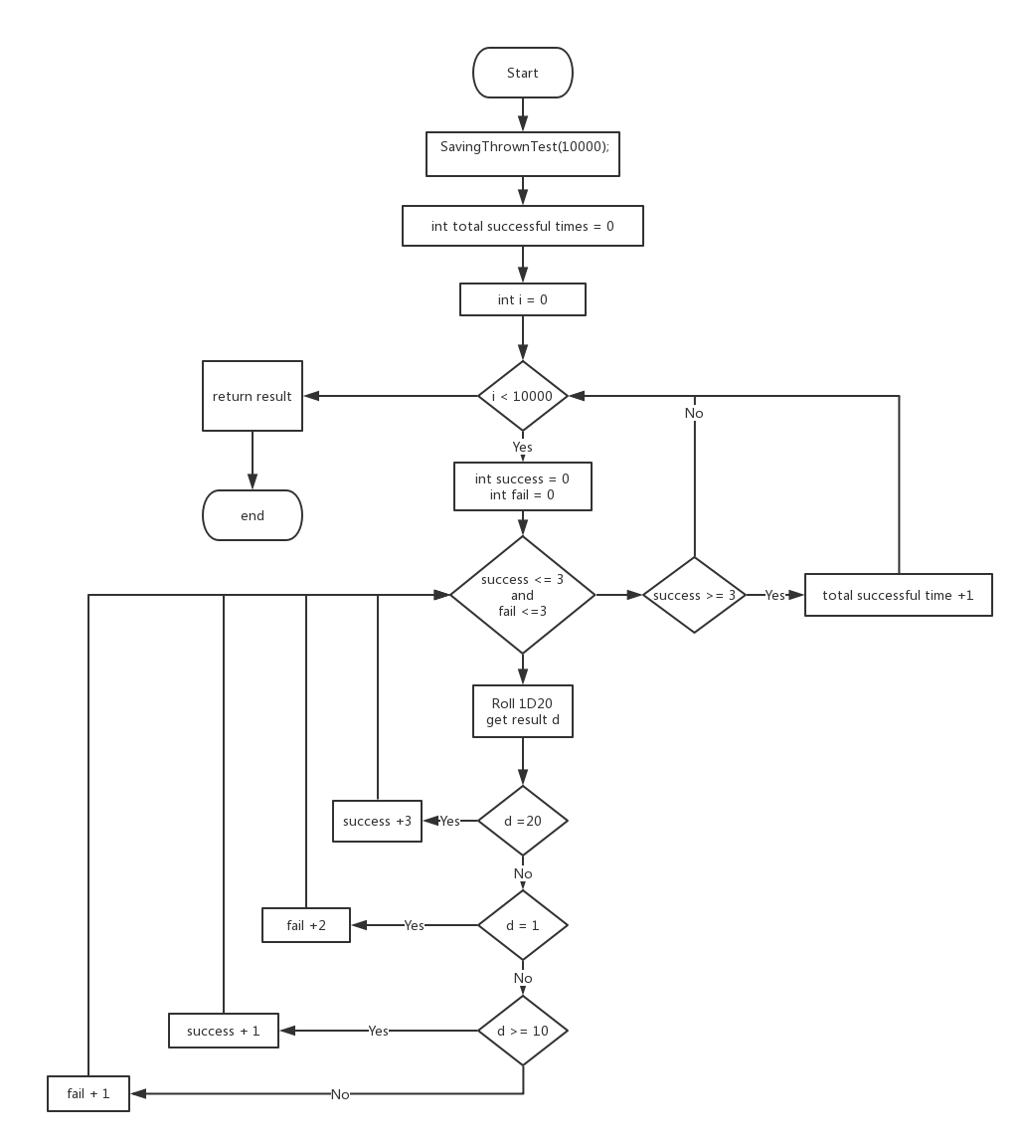

Figure IV: Saving Throw Test Process

6.2. Version 2.2

6.2.1. Improvement for Classes

In this version, there are some more classes added, ***Dice***, ***Statue***, ***Unit***, ***Player***, ***Ability***, ***AbilityMod***, ***Skills***, ***EnemyAttack***, ***Enemy***, ***Weapon***, ***Armor***, ***ACMod***, ***AttackChecker***, ***UnityBase*** and ***EquipmentBase***.

***Dice***class is a class to handle dice and such information. The user could create a new type dice by using ***new Dice("******nDr + i")***. Inside the bracket, by change ***nDr + i*** to define a new dice, and the class will handle information to separate int value for later use.

***Statue*** class contains statue information only, NAD means normal statue, advantage statue, and disadvantage statue.

***Unit*** class inherits *Statue* class. It contains information about *health*, *maxhealth*, ***Ability*** class, ***AbilityMod*** class, and *armorClass*. This class defined the basic attributes for a unit and it could be inherits by ***Player*** class or ***Enemy*** class.

***Player***class inherits ***Unity*** class, and it is the most complex class in this version. It records information for a player character, *pRace* (player character race), *pCass* (player character class), *primaryAbility*, *hitDice*, *skills*, *proficiencyBonus*, a ***EquipmentBase***class eb for equipment information, *weapon* and relative lists, *armor* and relative lists, and *ExtrallCapacity*. To create a player character, just need to use ***Player(Race pRace, Class pClass,*** ***EquipmentBase eb, int proficiencyBouns)***, to set player character race, player character class, equipments (weapons and armors) information, and player character proficiency bonus. Then, the class will automatically set *Ability* for the player character base on the *primaryAbility*, calculate ***AbilityMod****,* calculate *skills*, *hitDice*, *weapon*, and *armor*. Users could run ***GetCopy()*** insider the class to get a copy of this player character with the same *pRace*, *pClass*, ***EquipmentBase***, and *proficiencyBouns*, however, it will automatically recalculate other information such as ***Ability***, ***AbilityMod***, ***skills***, a new random *weapon*, and a new random *armor*.

***Ability*** class includes *STR*, *DEX*, *CON*, *INT*, *WIS*, and *CHA* for ability.

***AbilityMod*** class includes *STR*, *DEX*, *CON*, *INT*, *WIS*, and *CHA* for ability modify. The set an ***AbilityMod*** class, code need to run base on the ***Ability***class. Then, the code will do the same method like ***CalculateMod()*,** which shows in section 6.1.1., and calculate values for ability modify.

***Skills***class is designed to calculate 18 skills value automatically and a skill check function. To set *skills*, user need to input *AbilityMod*.

***EnemyAttack*** class is for *Enemy* use, and it concludes two type of attack mode, melee attack and ranged attack. To set it, just need to run ***EnemyAttack(******Dice meleeAttack, int meleeAttackHitModify,*** ***Dice rangedAttack, int rangedAttackHitModify, int modify)***, where *Dice meleeAttack and Dice rangedAttack* used ***Dice*** class. If an enemy only has one attack mode, just need to set the other dice to “0D0 + 0”.

***Enemy***class is similar with ***Player***class, but simpler. It inherits ***Unit*** class and contains variable for the enemy like *name* and *hitDice*.

***Weapon***class requires *name*, *type* (*SimpleMeleeWeapon*, *SimpleRangedWeapon*, *MartialMeleeWeapon*, or *MartialRangedWeapon*), *damageDice*, *range* (*Melee* or*Ranged*). And *isFiness* information for a weapon.

Similar with ***Weapon*** class, ***Armor***class require information like *name*, but some of them are different such as *type* (*LightArmor*, *MediumArmor*, *HeavyArmor* or *Shield*), *armorClass*, an ***ACMod***(armor class modify information), *StrNeed* (strength need to wear it), a statue for *Stealth*.

***ACMod***class is work with ***Armor***class. It tells if the weapon’s *armorClass* has Dexterity modify bonus, and how much it is if has.

***AttackChecker***class, contains two Boolean variables, one for recording if the attack checker success or not, and the other one recording critical or not. This benefit for retuning result in a function together.

***UnityBase*** class is a place contains player characters and enemies information. Inside the class, it contains two list, one for players, and the other one for enemies.

***EquipmentBase*** is a similar class with ***UnityBase*** class but contains information for weapons and armors. Two lists in the class, one for weapons, and the other one for armors.

6.2.2. Exploration Test

The process is same which shows in the section 5.2.2., but before every single test, it is better to get a copy of the current test player character. Due to the improved classes, this version could do it by running code

***Player copy = player.GetCopy();***

***exploratiionResult += copy.skills.******SkillsCheck(ExplorationSkillsInfluence, 1, copy);***

Moreover, inside the *SkillsCheck(double[] checkList, int times, Player p)*, it puts the copy of the player character’s skills into a list in order and create a list for the different influence point. Then, in the *for* loop, it is easy to manage by giving a number of indices.

*SkillsCheck(double[] checkList, int times, Player p)* use a *for* loop for counter test time, and add all result together to get the result for $R_{e}$. Every skill will be tested under the normal statue, advantage statue, and disadvantage statue. These influence point $I_{advantage}$, $I_{normal}$, and $I_{disadvantage}$ are 3, 8, and 3. It means most test is under the normal statue, and some test will under the advantage or disadvantage statue, which make sense for the gameplay. It use another function *SkillCheck(int skill, int times, Player p)* to test the single skill.

*SkillCheck(int skill, int times, Player p)* will test the pass rate for this skill, and times different influence point for the different levels quests.

Then, once the *for* loop end, add all skills’ result together to get $R_{e}$. The logic could be demonstrated in the Figure V.

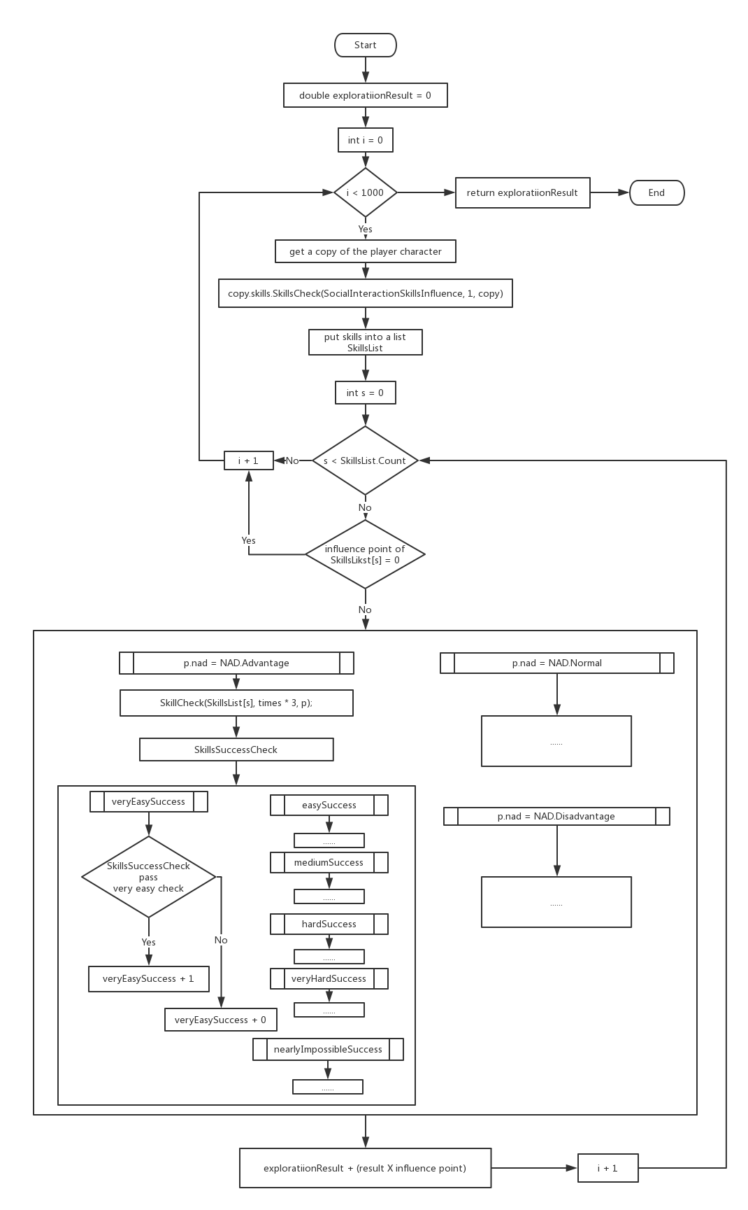

Figure V: Exploration Test Process

6.2.3. Social Interaction Test

Social Interaction test is same with the exploration test but with the different influence point. Therefore, the result is calculated in same approach with section 6.2.2. but different influence point.

By using the same way,

***Player copy = player.GetCopy();***

***socialInteractionResult += copy.skills.SkillsCheck(SocialInteractionSkillsInfluence, 1, copy);***

it is easy to get the result of the player character in the social interaction test.

6.2.4. Combat Test

Combat part is different and complex than the other two tests. It requires enemy join into the battle.

***BattleCheck(1000, player, ub.enemies)***

There is a list for all enemies in the ***UnitBase*** class. To get the result, just use a copy of the player character to battle with every single enemy’s copy inside the list one by one and add result together.

***Player pCopy = p.GetCopy();***

***Enemy eCopy = e.GetCopy();***

***SimulateBattle(pCopy, eCopy);***

Every battle test, the copy of the player character and the copy of the enemy are varied, because the health and other variable will be automatically recalculated. Therefore, the test could be set to a random environment but in the limitation. Then, both copies roll dice to decide which one will attack first. Until one of them died (health point equal or less than zero), they will attack each other in order. In the further test, due to the bug, then in the code the round time is limited in 40 rounds. Then the result is

***result = (e.health <= 0)? 1: 0;***

Then, the logic of combat test could be described as the Figure VI

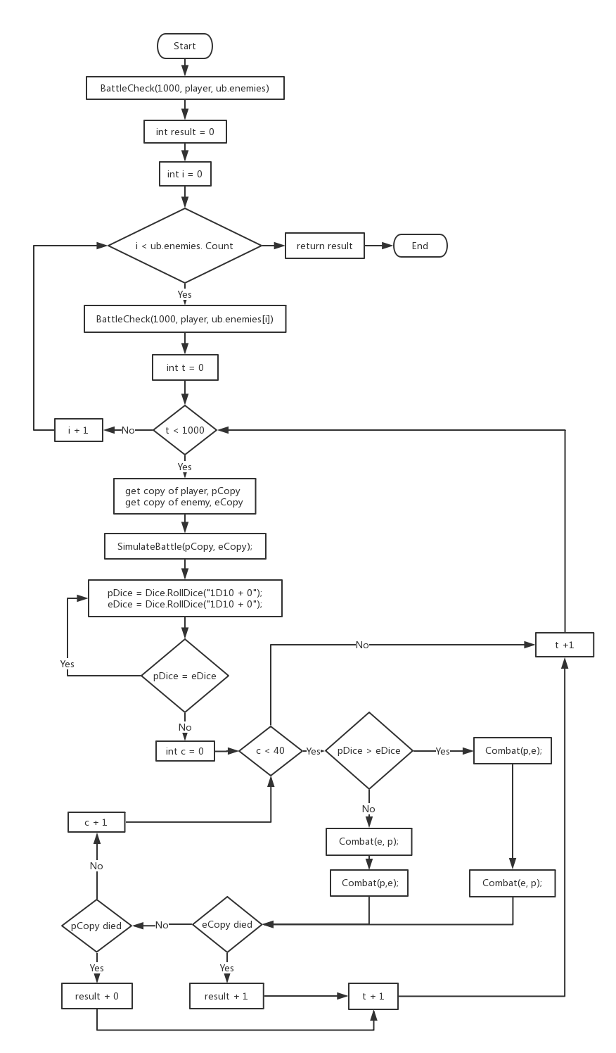

Figure VI: combat test process

6.3.5. Test Result

When finish exploration test, social interaction test, and combat test, time them with different influence point to get the result of the player character.

***double result = 0;***

***exploratiionResult = exploratiionResult / 300;***

***result += exploratiionResult;***

***socialInteractionResult = socialInteractionResult / 300;***

***result += socialInteractionResult;***

***double combatResult = BattleCheck(1000, player, ub.enemies);***

***result += combatResult;***

Similarly, by using a *for* loop, it is easier to test all combination of player character’s class and race.

7. Result and Analyses

All result could be found in the *DnDTestResult.xlsx* in GitHub. In this section, this report shows the test result and describe them.

**//TODO, put link here**

7.1. Ability Check Result

This report test 10,000 times (10k), 1,000 times(1k), and 100 times and get the result below *Table IV*. More detail information about it could be found at Github *DnDTestResult.xlsx*, label *MissionLvlTest*.

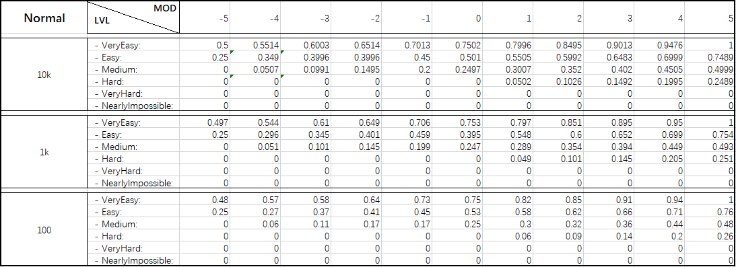

Table IV: (Normal statue)10k, 1k, 100 test result

The result shows that 10k test is more approach to a percentage and enough for test. 1k and 100 test less times so that the deviation with 10k is large some time. Therefore, for the later test, this report set test time as 10k. Then, using the same way, to get Table V and Table VI under the different statue.

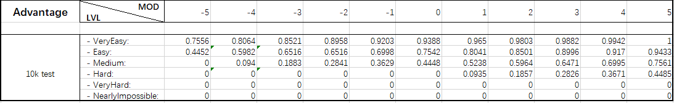

Table V: (Advantage statue)10k, 1k, 100 test result

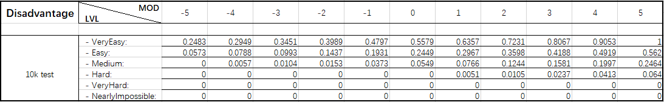

Table VI: (Disadvantage statue)10k, 1k, 100 test result

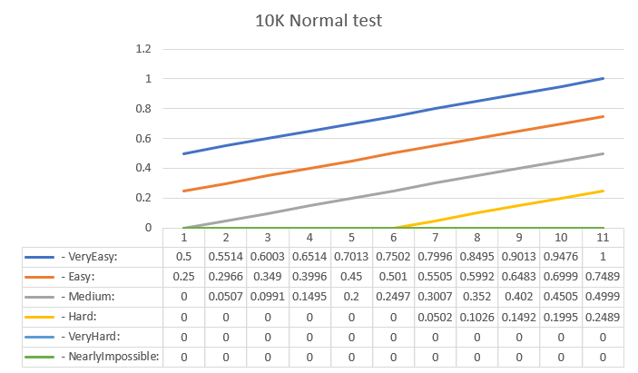

Figure VII: 10k Normal ability test

Putting these data into a graph, for example, draw Table IV into a graph like Figure VII, the relationship of ability modify and mission difficult level is a lineal relationship. Therefore, it could be wrote as $y=mx+c$ and ***m*** could be calculate by using

$m= \frac{\sum_{i}^{N}{(x_{i}- \overline{x})(y_{i}- \overline{y})}}{\sum_{i}^{N}{{(x_{i}-\overline{x})}^{2}}}$ [8]

Where ***m*** is the slop

***N*** is the number of data points

$\overline{x}$ is the mean value of value of $x_{i}$’s

$\overline{y}$ is the mean value of value of $y_{i}$’s

Using another function to calculate ***c***

$c= \overline{y}-(m × \overline{x})$ [8]

Then, for *veryEasy* quest under the normal statue, the pass rate could be described as

***y = 0.045x + 0.75***

Where ***x*** is the player character ability modify

***y*** is the pass rate

Keep doing this process, we can calculate other difficulty level quest pass rate under the normal statue and get below linear relation functions.

***veryEasy y = 0.050 x + 0.75***

***easy y = 0.050 x + 0.50***

***medium y = 0.027 x + 0.20***

***hard y = 0.025 x + 0.07***

***veryHard y = 0 x + 0.00***

***nearlyImpossible y = 0 x + 0.00***

Then, using the same way to draw graph under the advantage and disadvantage statue to get the Figure VIII and Figure IX. Details could be found at *DnDTestResult.xlsx* in GitHub.

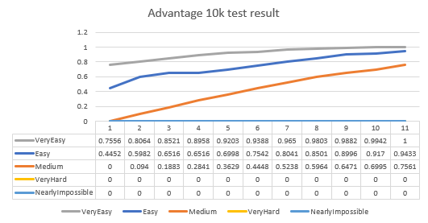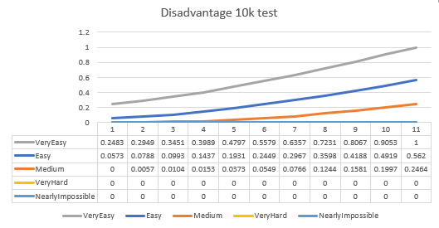

Figure VIII: 10k advantage ability test Figure IX: 10k disadvantage ability test

Calculate the linear relation functions again, then we can get Table VII below.

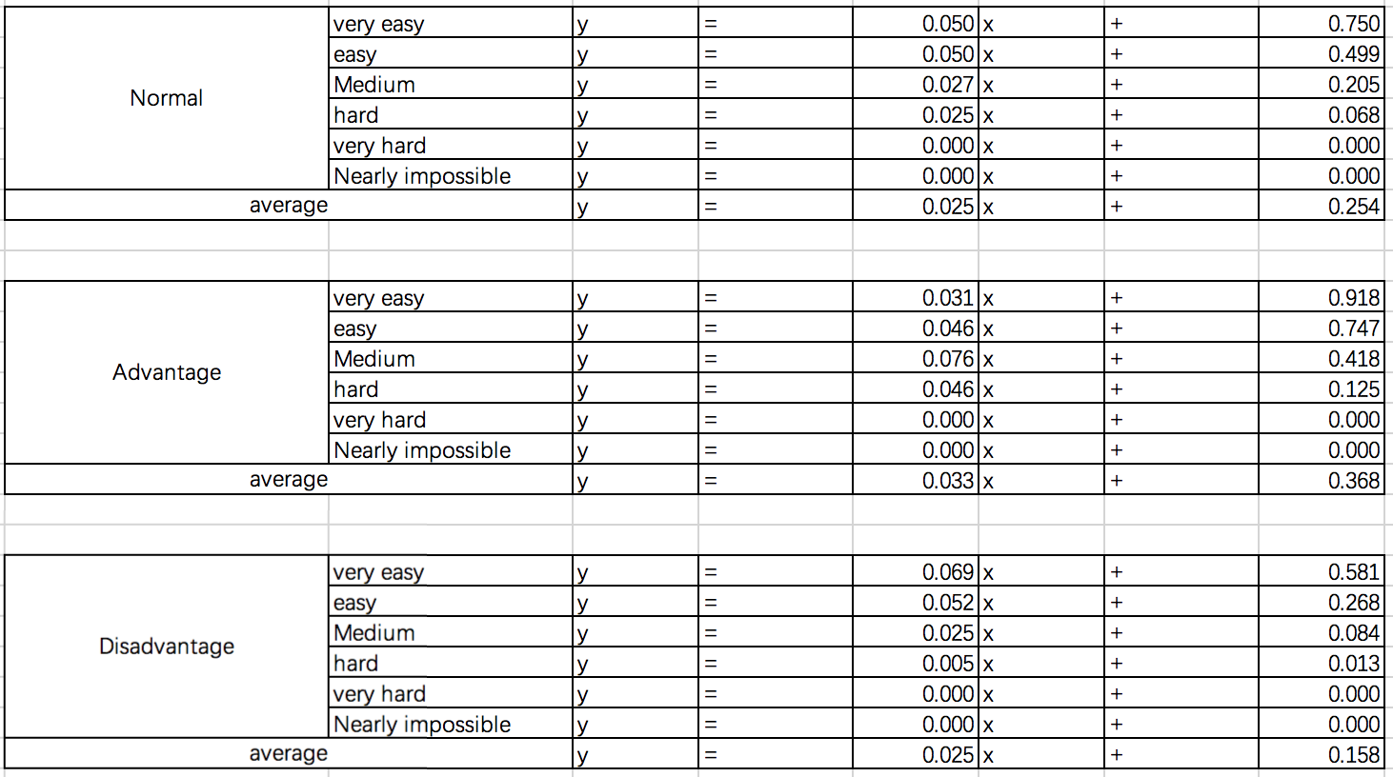

Table VII: Linear Relationship in Different Statue

By comparing and contrast data in Table IV, Table V, Table VI and Table VII, *advantage* statue cause more pass rate than *normal* and *disadvantage* statue. The reason is in the *advantage* statue, player character will roll dice twice and take the larger one as result, it makes sense for higher pass rate.

For the *veryHard* difficult level quest and the *NearlyImpossible* difficult level quest, player character cannot pass them at all statue. It could be explained by the threshold are 25 and 30, therefore in this test, the largest value of 1D20 is 20 which is less than 25 or 30. Hence, without modify, a player has no chance to larger than 20.

To fix it, in the next version, designer add a function to add bonus comes from the player character’s ability modify. However, generally, a player could use formulas in Table VII to calculate the pass rate for his player character during the game play. Just change ***x*** to sum of the player character’s ability modify and bonus, then get ***y*** as the percentage to manage strategy of game play.

7.2. Weapon damage result

In label of *meleeWeaponAfterDebug*, *RangedWeaponAfterDebug*, *MartialMelee*, and *MartialRange* in *DnDTestResult.xlsx* contain all type of weapons damage rate test result. Every single weapon has been tested at the different player ability modify and at the different enemy armor class. There is an example for a simple melee weapon (label *meleeWeaponAfterDebug*) “Club” test data in Table VIII

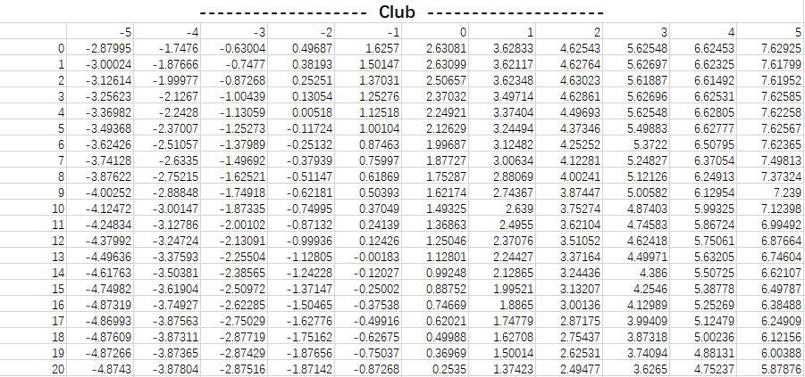

Table VIII: Club Weapon Damage

In Table VIII, the horizontal row, -5 to 5, is player character’s ability modify or can be simplify describe as bonus; the vertical column, 0 to 20, is enemy’s armor class. To find the damage of “Club” when a player character’s bonus is 3 and the enemy’s armor class is 6, just need to find column of 3 and row of 6 so that the damage rate is 5.3722. Therefore, if the player character hold more than one weapons, by checking those table and compare the result, it is easy to get idea which weapon might cause more damage under the circumstances.

Then, by using the same formula shows in section 7.1.

$$m= \frac{\sum_{i}^{N}{(x_{i}- \overline{x})(y_{i}- \overline{y})}}{\sum_{i}^{N}{{(x_{i}-\overline{x})}^{2}}}$$

$and$

$$c= \overline{y}-(m × \overline{x})$$

to calculate the linear relationship of weapons. However, due to the larger data of every weapon, hence, before calculating linear relationship function, find means of the weapons. For instance, “Club”, find means for damage as $x_{i}$ and easy for later calculations.



Table IX: Means of “Club”

By doing the same process, we can get the Table X. Larger ***m*** means how much damage in increase number of player character bonus, larger ***c*** means the basic damage when the player character bonus

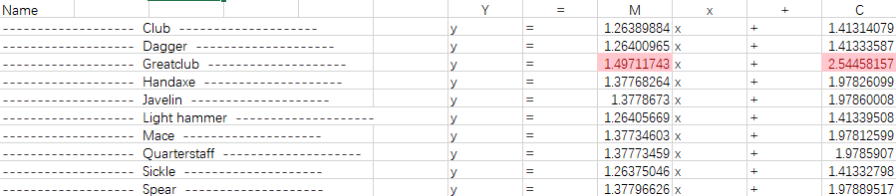

Table X: Simple Melee weapons’ linear relationship

In Table X, “Greatclub” has the largest ***m*** and the largest ***c***, which means this weapon could cause more damage than other simple melee weapons. Therefore, base on the test, if a player character equips “Greatclub”, it will bring more benefit during the battle.

Same as the pervious process, in *DnDTestResult.xlsx*, labels of *RangedWeaponAfterDebug*, *MartialMelee*, and *MartialRange* can leading-out Table XI, Table XII, and Table XIII.



Table XI: Simple Ranged weapons’ linear relationship

Table XI shows “Crossbow,light” deals more damage than other simple ranged weapons.

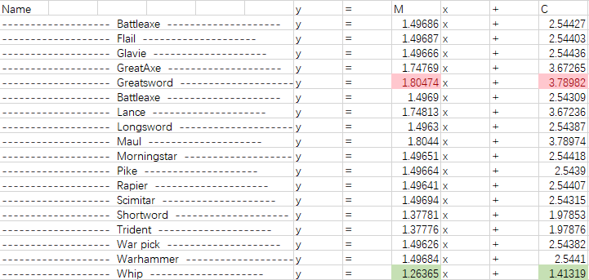

Table XII: Martial Melee Weapons’ Linear Relationship

Table XII tells that “Greatsword” deals more damage than other martial melee weapons; “Whip” deals less damage than other martial melee weapons.

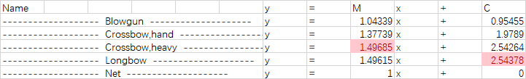

Table XIII: Martial Ranged Weapons’ Linear Relationship

Table XIII shows “Crossbow,heavy” deal more damage when the player character’s bonus increase; “Longbow” deal more damage when the player character has no bonus.

7.3. Saving Throw Test Result

By using the method described in section 5.1.3., and code in 6.1.4., this report could get the result of saving throw below

***Total test Times: 10000***

***Total Success Times: 5960***

***Total fail Times: 4040***

By using ***Total Success Times*** divide by ***Total test Times***, saving throw pass rate could be calculated. Therefore

$$Saving Throw pass rate= \frac{total success times}{total test times}=\frac{5960}{10000}=59.6\%$$

It shows a player character’s saving throw pass rate is not 50%, but higher 59.6%.

7.4. Race and Class combination Test

This test is based on programmer version 2.2, which described at the section 5.2. and section 6.2.. The result of this test is record at the label *all combination v2* on *DnDTestResult.xlsx* in GitHub. All Test result is shows in Table XIV in appendix.

7.4.1. Exploration and Social Interaction Test Result

Then, separate Table XIV to four different tables base on the result of total test (Table XV), exploration test (Table XVI), social interaction test (Table XVII), and combat test(Table XVIII).

By skim through Table XVI and Table XVII, exploration and social interaction test parts, *Halfling: Stout* and *Halfling: Lightfoot* are good at these two parts. Looking tow label *AllTable* in *DnDTestResult.xlsx*, which contain all combination information, the common capacity they have are

***Dexterity +2***

***Reroll D20 when attack roll, Ability Check, or Saving Throw, once***

The second ability may be the reason why their scores are larger than other combination, for they both get chance to reroll dice one more time when they fail at the first time.

For the 10 lowest score in exploration test, *Human* occupy 10; for the 10 lowers score in social interaction, *Human* occupy 9. Therefore, *Human* is week at both parts. By looking through *Human*’s capacity

*Strength +1*

*Dexterity +1*

*Constitution +1*

*Intelligence +1*

*Wisdom +1*

*Charisma +1*

These bonuses are very week, for two ability bonuses must influence ability modify, but one bonus is depending. For example, if a player character’s ability is 16, 14, 14 ,12, 10, and 10 for *Str*, *Dex*, *Con*, *Int*, *Wis*, and *Cha*. Adding 1 more for every ability, the player character’s ability will become 17, 15, 15, 13, 11, and 11. Visually, every ability gets increasement, but the character’s ability modify is same, for more detail about ability modify could be found at previous Table I. Hence, it could be a reason why *Human* did not good at these two parts.

Skimming through Table XVI and Table XVII again, the rule could be found that

***Race* influence more than *Class* in exploration and social interaction test**.

The reason could be this test evaluates a player character’s ability scores, higher scores will bring more benefits for the player character.

In these two parts, *Race* of *Halfling: Stout*, Halfling: *Lightfoot*, *Dwarf: Mountain Dwarf*, *Half-Orc*, and *Dragonborn* have more benefits compare with other Races; *Human*, *Tiefling*, *Elf: Dark Elf*, *Half-Elf*, and *Tiefling*, have less bonus compare with other Races.

7.4.2. Combat Test Result

Combat test rank result can be found at Table XVII. It shows the combination of *Fighter + Half-Orc* is much higher than other class and race combination, and higher 8.75% than the second highest combination. Class of *Fighter* benefit a player character can be proficiency for all weapons and all armors, the hit dice of Fighter is D10 which is the second highest hit dice in all Class, just after D12 of Barbarian. Moreover, Race of *Half-Orc* has capability *Relentless Endurance* and *Savege Attacks*, which are benefit for combat. Therefore, if a player character’s race is *Half-Orc* or class is *Fighter*, the player character’s combat score will be improved.

Class of *Roger*, *Palading* and *Ranger*, race of *Halfling: Lightfoot* and *Halfling: Stout* also did a good job in the combat test. For the class of *Roger*, this class player character is proficiency for all equipped weapons at the beginning, and it could be a reason why its score is higher; for the class of *Palading* and *Ranger*, both of them has higher hit dice, D10, than other classes, it could benefit for combat because it cause a player character could taken more damage before died. Race of *Halfling: Lightfoot* and *Halfling* have a same capability

***Reroll D20 when attack roll, Ability Check, or Saving Throw, once***

It lets a player character reroll D20 when the first attack check fail, it makes the player character could have more chance to pass the attack check and deal damage to enemies.

However, for race of *Human*, *Half-Elf*, *Dragonborn*, and *Dwarf: Mountain Dwarf*, class of *Wizard*, *Sorcerer*, and *Monk* did not well in combat test. For class of *Human*, *Half-Elf*, *Dragonborn*, and *Dwarf: Mountain Dwarf*, they only improved some abilities for a player character, not like class of *Halfling: Lightfoot* or *Halfling* have capabilities. For *class* of *Wizard* and Sorcerer, they have the smallest hit dice, D6, which means they could take less damage before they died. For class of *Monk* has D8 hit dice but has no proficiency armors.

However, except top 20 and bottom 20, the middle 128 combinations has less relationships and less variances. **Generally, Class of *Roger*, *Palading* and *Ranger*, race of *Halfling: Lightfoot* and *Halfling: Stout* are good at combat, but race of Human, Half-Elf, Dragonborn, and Dwarf: Mountain Dwarf, class of Wizard, Sorcerer, and Monk are week at this part.**

7.4.3. Total Test Result

Add result get from section 7.4.1. and section 7.4.2. together, this report orders them together to get Table XVIII. **It shows that race of** ***Half-Orc*, *Halfling: Stout*, and *Halfling: Lightfoot* gets better result than other races, and most player character with class** ***Fighter*, or *Rogue* could get higher scores than other classes.** This result is similar with the result from section 7.4.1. and section 7.4.2., so that during the gameplay, creating a character by choosing class from *Fighter*, or *Rogue, and choosing race from Half-Orc*, *Halfling: Stout*, and *Halfling: Lightfoot* could get better performance than other player characters.

8. Discussion and Conclusion

This report has designed a programmer to test the balance in *D&D 5e*. Two version of programmers were designed to test *D&D 5e* at different aspects. Via the version 1.0, we could get result that

1) tables for ability check pass rate under the *normal* statue

Figure VII, Table IV and Table VII

2) tables for ability check pass rate under the *advantage* statue

Figure VIII and Table V

3) tables for ability check pass rate under the *disadvantage* statue

Figure IX and Table VI

4) simple melee weapons’ damage rate

Table X

5) simple ranged weapons’ damage rate

Table XI

6) martial melee weapons’ damage rate

Table XII

7) martial ranged weapons’ damage rate

Table XIII

8) saving throw pass rate

59.6% (10,000 test)

10) 168 race and class combination test result

Table XIV, Table XV, Table XVI, Table XVII and Table XVIII

The result shows outcomes like Table XVIII below

|  |  |  |
| --- | --- | --- |
|  | **Class** | **Race** |
| **Good**  **performance** | *Fighter* and *Rogue* | *Half-Orc*, *Halfling: Stout*, and *Halfling: Lightfoot* |
| **Bad**  **performance** | *Wizard* and *Sorcerer* | *Half-Elf*, *Human*, *Dragonborn* and *Gnome: Forest Gnome* |

Table XVIII: Unbalance Classes and Races During the Test

The test illustrates that not every class and race is fair and balanced. However, there are some lack of these two programmers, therefore, in the future, there are some place to be improved later.

1) Add spells and magic to player character

2) Add all enemies, because for current version, only half enemies added for testing

3) Add a level system for player character

4) Improve influence point for exploration test and social interaction test

5) Improve combat progress

6) Make a character choose weapons and armors base on the test result, not random

7) Modify influence point when need

8) Simplify code and fix bugs when encountered

9. References //TODO: Edit format to IEEE style

[1] [https://ffxiv.consolegameswiki.com/wiki/Attributes Aug/5](https://ffxiv.consolegameswiki.com/wiki/Attributes%20%20Aug/5)th

[2] Schick, Lawrence (1991). Heroic Worlds: A History and Guide to Role-Playing Games. Prometheus Books. p. 130. ISBN 0-87975-653-5.

[3] <https://www.g-cores.com/articles/93885> Aug/7th

[4] Peterson, Jon (2012). Playing at the World. Unreason. p. 496. ISBN 978-0-615-64204-8.

[5] Cowie, Doug (October 1983). "Game Reviews". [*Imagine*](https://en.wikipedia.org/wiki/Imagine_(AD%26D_magazine))(review). TSR Hobbies (UK), Ltd. (7): 42.

[6] <https://www.g-cores.com/articles/94156> Aug. 7th

[7] Appelcline, Shannon (August 3, 2006). ["Wizards of the Coast: 1990 – present"](https://web.archive.org/web/20060824022118/http:/www.rpg.net/columns/briefhistory/briefhistory1.phtml). *A Brief History of Game*. RPGnet. Archived from [the original](http://www.rpg.net/columns/briefhistory/briefhistory1.phtml) on August 24, 2006. Retrieved September 1, 2006.

[8] CE902 Spring Term Lecture 4

Correlation and Linear Regression

Michael Gardner

CE902 Professional Practice and

Research Methodology

[9] <http://www.goddessfantasy.net/bbs/index.php?topic=96989.0> Aug.20th

[10] [https://forum.rpg.net/showthread.php?801574-Does-the-Class-Balance-of-the-5E-PHB-Core-Classes-stay-close-all-the-way-from-Level-1-to-Level-20/page2 Aug.20th](https://forum.rpg.net/showthread.php?801574-Does-the-Class-Balance-of-the-5E-PHB-Core-Classes-stay-close-all-the-way-from-Level-1-to-Level-20/page2%20Aug.20th)

[11] <https://www.reddit.com/r/DnD/comments/2erd88/5e_class_balance_make_me_feel_better/> AUG.20th

10. Appendix



Table XIV: All Combination Test Result



Table XV: Total Test Score highest to lowest



Table XVI: Exploration Test Score highest to lowest



Table XVII: Social Interaction Test Score highest to lowest



Table XVIII: Combat Test Score highest to lowest